H.T No
Regulations:
A19

Sreenidhi Institute of Science and Technology
(An Autonomous Institution)
Code No: 7P256 Date: 19-April-2022 (FN)

M.Tech I-Year II-Semester External Examination, April/May - 2022 (Supplementary)
MACHINE LEARNING (CSE and CS)

Time: 3 Hours Max.Marks:70

Note: a) No additional answer sheets will be provided.
b) All sub-parts of a question must be answered at one place only, otherwise it will not be valued.
c) Missing data can be assumed suitably.

ANSWER ANY 5 OUT OF 8 QUESTIONS. EACH QUESTION CARRIES 14 MARKS.

Bloom's Cognitive Levels of Learning (BCLL)

Remember | L1 | Apply | L3 | Evaluate | L5
Understand | L2 | Analyze | L4 | Create | L6

 |  |  | BCLL | CO(s) | Marks
1. | a) | Explain issues in machine learning. | L2 | CO1 | [7M]
 | b) | Design single perceptron model for simulate simple AND function. | L6 | CO1 | [7M]
2. | a) | Design MLP for XOR problem. | L6 | CO2 | [7M]
 | b) | Explain Different Output Activation Functions. | L3 | CO2 | [7M]
3. | a) | How ID algorithm construct decision? Explain it. | L1 | CO3 | [7M]
 | b) | Find root node of decision tree using Id Algorithm using below data set.  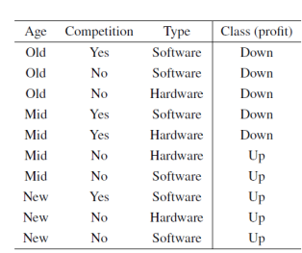 | L4 | CO3 | [7M]
4. | a) | Explain principal component Analysis (PCA). | L1 | CO4 | [7M]
 | b) | Analyze different algorithms to dimension reductions in data . | L4 | CO4 | [7M]
5. | a) | Explain Variable Elimination Algorithm. | L2 | CO5 | [7M]
 | b) | How bayesian networks used in machine learning? | L3 | CO5 | [7M]
6. | a) | Discuss about KBANN Algorithm. | L2 | CO6 | [7M]
 | b) | Give example on Explanation based learning. | L2 | CO6 | [7M]
7. | a) | Give example for not linear separable and linear separable. | L2 | CO1 | [7M]
 | b) | Write Radial Basic Function Algorithm and its advantages. | L1 | CO2 | [7M]
8. | a) | Explain genetic algorithm basic operations. | L2 | CO4 | [7M]
 | b) | Discuss about proposal distribution. | L2 | CO5 | [7M]
-- 00 -- 00 –

